GIT ASSIGNMENT 2 :

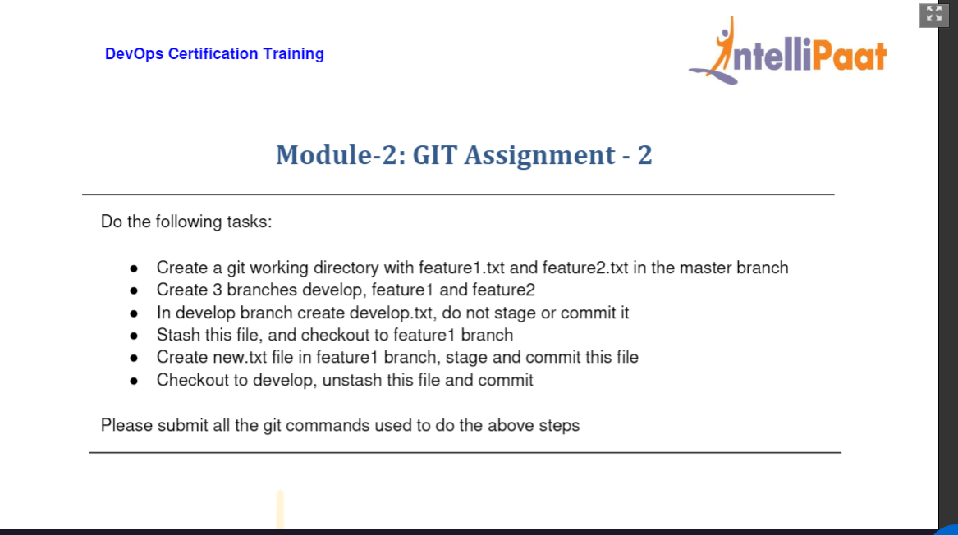

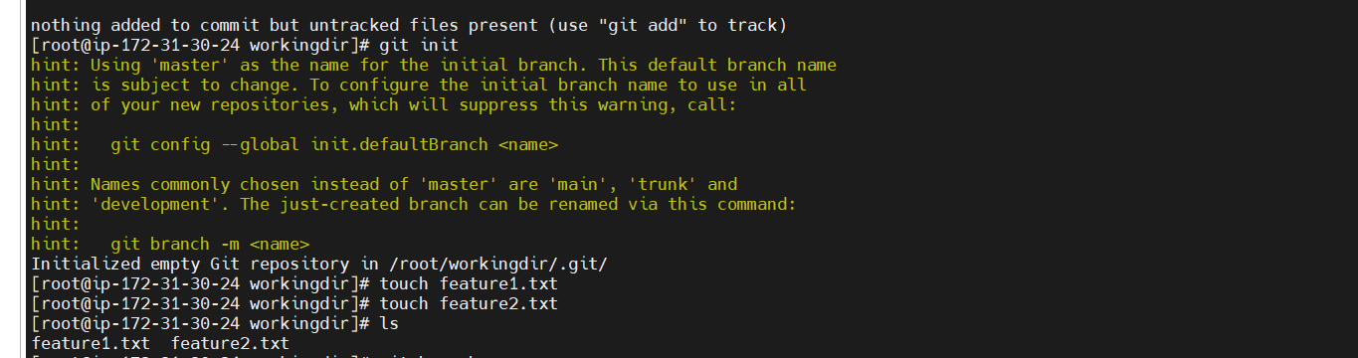

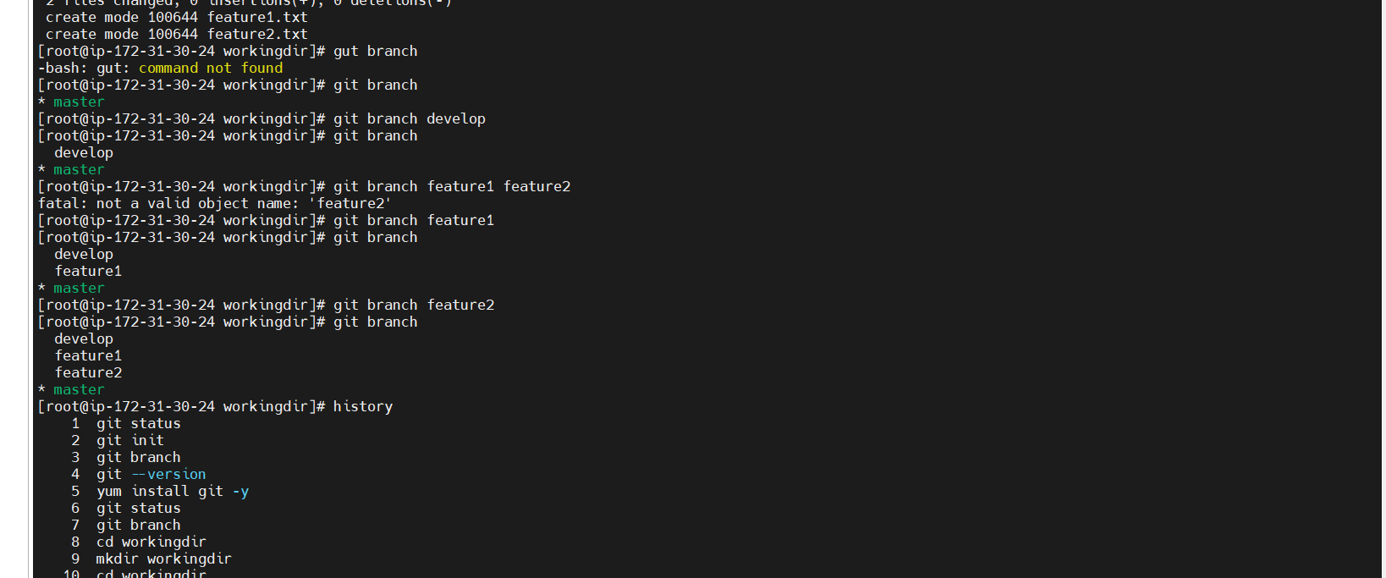

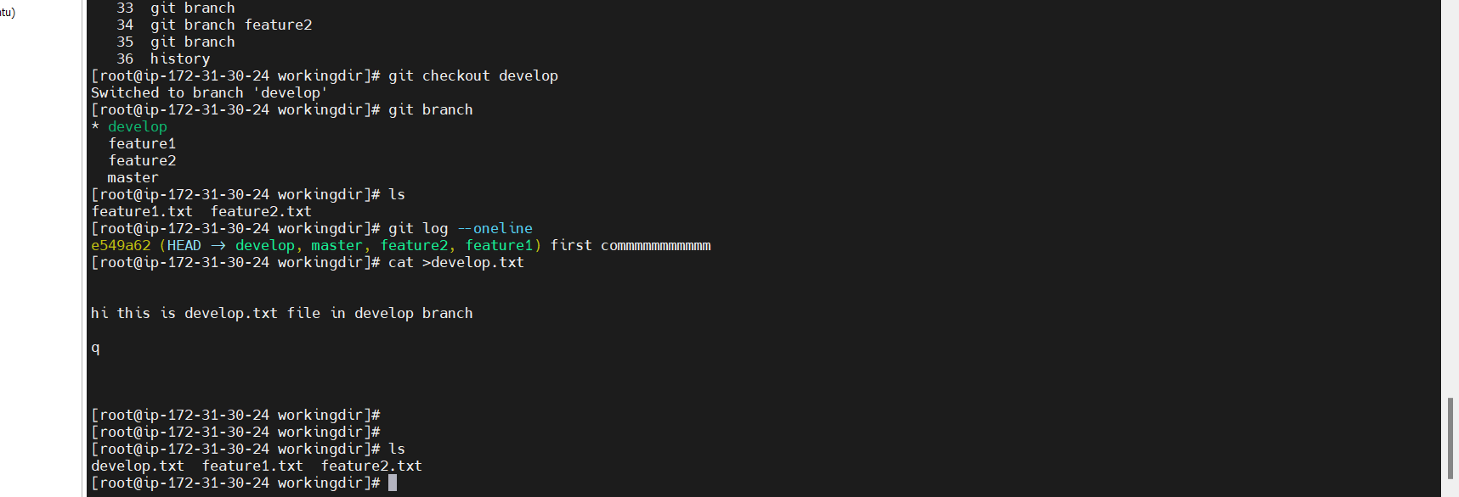

Stashing develop.txt

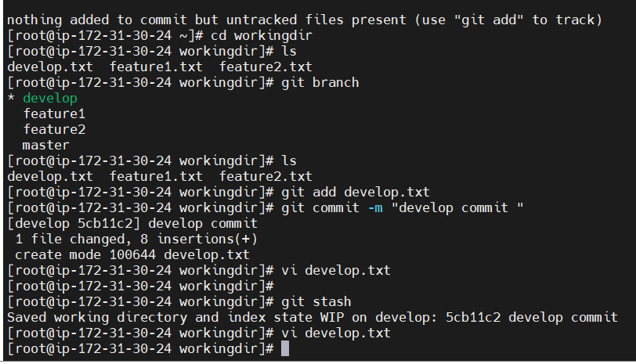

git init

2 git status

3 cd workingdir

4 ls

5 git branch

6 ls

7 git add develop.txt

8 git commit -m "develop commit "

9 vi develop.txt

10 git stash

11 vi develop.txt

12 history

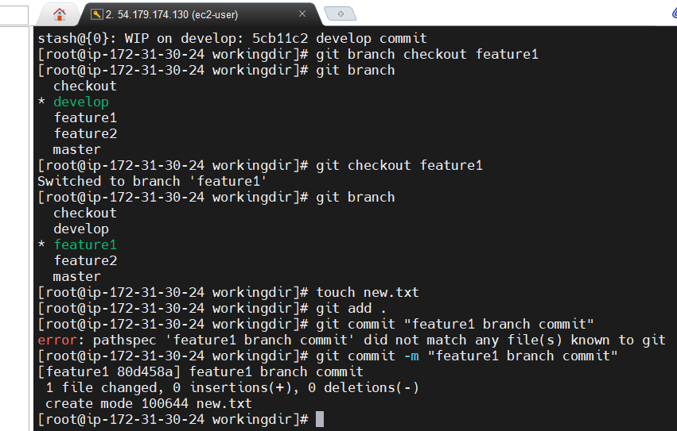

git stash list

15 git branch checkout feature1

16 git branch

17 git checkout feature1

18 git branch

19 touch new.txt

20 git add .

21 git commit "feature1 branch commit"

22 git commit -m "feature1 branch commit"

23 history

[root@ip-172-31-30-24 workingdir]#

Checkout to develop ,unstash the file and commit it :

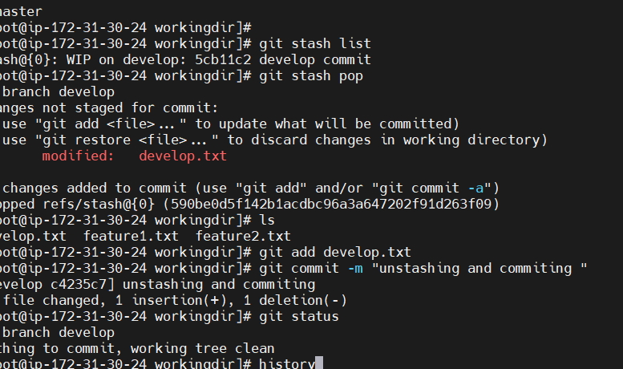

To unstash :

Git stash pop

1 git init

2 git status

3 cd workingdir

4 ls

5 git branch

6 ls

7 git add develop.txt

8 git commit -m "develop commit "

9 vi develop.txt

10 git stash

11 vi develop.txt

12 history

13 cat develop.txt

14 git stash list

15 git branch checkout feature1

16 git branch

17 git checkout feature1

18 git branch

19 touch new.txt

20 git add .

21 git commit "feature1 branch commit"

22 git commit -m "feature1 branch commit"

23 history

24 git checkout develop

25 git branch

26 git stash list

27 git stash pop

28 ls

29 git add develop.txt

30 git commit -m "unstashing and commiting "

31 git status

32 history